**Understanding Electricity Prices in Texas**

**Final Project Report**

**EXECUTIVE SUMMARY:**

In Texas, the cost of electricity is determined by the amount of demand generated by the consumer. Numerous factors affect the price of energy. The project's main goal is to visualize real-time data on electricity prices throughout Texas. This information can be used by the government to control the impending power outage and maintain the stability of electricity costs. Additionally, the public can better understand the prices and data's key insights, allowing them to manage their electricity use and lower their bills. Electricity prices from 2019 to 2021 are included in the figures. Numerous factors, including load (the demand for electricity) and power generation, influence prices. Electricity costs will be comparatively high in 2021. Electricity's average price has changed. The most significant influencing elements are power generation and rising consumer demand for electricity.   
  
**BUSINESS QUESTIONS:**

1. Explore if there is a seasonal pattern in electricity prices. Are there variations in the pattern across the regions?
2. How has power generation changed from 2019 to 2021 (or any subset of the data that you choose)?
3. What is the relationship between how power is generated and electricity prices?
4. What is the relationship between weather variables and electricity price? Does the relationship change across the regions?
5. What is the impact of changing the level of detail (one hour vs one day) on the results?

**INTRODUCTION:**

Electricity Prices in Texas are rising high due to increased demand in electricity consumption and low power generation. Additionally, there are other factors like load on the power grids, power generated and consumed in each location, weather variables like Temperature, Windspeed and Humidity. The goal is to better understand fluctuations and reveal the hidden insights that impact the electricity prices providing a better dynamic dashboard in tableau.

**DATA PREPARATION:**

The dataset contains nine files, three of which are annual electricity pricing files from 2019 through 2021. In addition, three files contain data on power generation from 2019 to 2021. The other three files concern load (electricity demand), weather conditions, and each weather variable's description.

To accurately draw the hidden insights from the data, it has to be cleaned and prepared very well. Initially, Tableau prep is used to remove null values, and duplicates from all the files. Additionally, three files from 2019 to 2021 are joined using union steps. Then the pricing data files and generation files are carefully mapped using a join step. Furthermore, Weather variables have data for each region in each column which makes it difficult for analysis. To eliminate this, a pivot step is used where 27 columns are transformed into 4 columns named Location, Dry bulb temperature, Wind Speed, relative humidity. Finally all the data files joined together and proceeded for analysis in Tableau desktop  
  
**KEY INSIGHTS:**  
  
Several patterns and variances may be detected in power pricing in Texas, which enables us to dive deep into the study and obtain some understanding of data. The following items include a quick analysis of the power price.

1. The electricity price has been fluctuating in all months, but has the highest price in February during the winter season. To drill down data, prices can be looked into each year. When looked into each year, the price has been increasing sequentially.
2. Higher temperatures (summer months) correlate with moderate prices (**85.23** in July), while colder months like February show the highest spike in prices (**508.6**) despite lower average temperatures (**50.24**). This suggests external factors, such as grid reliability or unexpected demand, influencing prices.
3. Power generation in January, February, and August has been high, because of excess usage of cooling systems and heaters in peak summers and winters.
4. The level of detail from price in a day to price in an hour help us understand the peak usage hours. There is a high spike in the 3rd week of month which can be helpful to increase power generation so that load is not too much in power grids. Drilling down to an hour, gives details about the peak hour usage.

**DASHBOARD:**

The dashboard includes key insights into electricity pricing and factors influencing it. The link to the dashboard is attached below

Attach dashboard link

**STORYLINE:**

The storyline gives a sequence of visualizations of electricity pricing in Texas and conveys information about what are the key factors influencing it. The link for the storyline is provided below.

Attach Story Link

**IDEAS FOR FURTHER ANALYSIS:**

To do further analysis,

1. A visual tool can be used to build a relationship between the load and price to see if load exhibits a significant relationship with price. Additionally, the load can be analyzed at each hour. Level of details from day to hour will help gain more insights
2. A visual tool can be built to analyze the peak demand or load and renewable energy power generation to ensure better contribution towards green energy and prices can be very low.

**DATA CLEANING:**

The data has a lot of null values, which can be difficult for analysis. Additionally, the weather variables had each column for each region. These columns are moved into rows using the pivot step. When the tables are joined, it creates 9 additional rows for each date because of 9 locations in the data. This makes the numbers for power generation, price and load jump into millions which gives wrong insights. To avoid this the exact numbers are calculated using calculated fields.

**SUPPORTING ANALYTICS:**

1. **Descriptive Analytics:  
   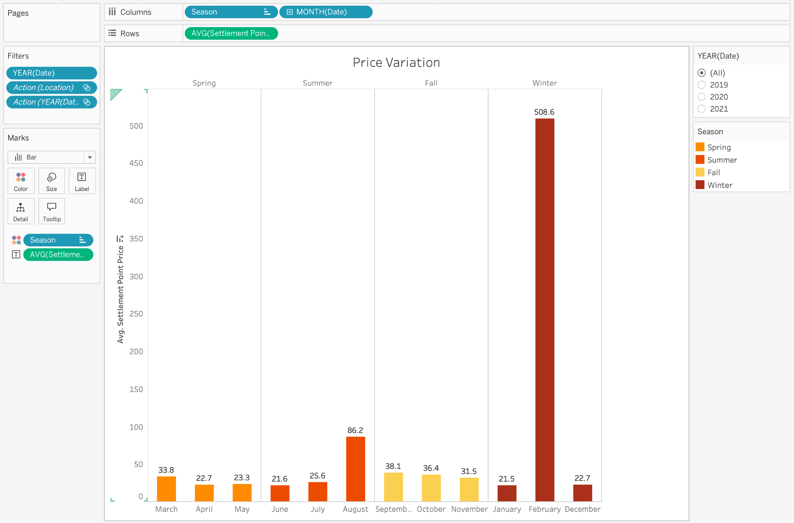**

This visual tool gives descriptive statistics for electricity prices in each. Prices are fluctuating each month but they are very high in August and december. The average price in August is 86.2 and February is 508.6. Those times are peak summers and winters.

1. **Diagnostic Analytics:**

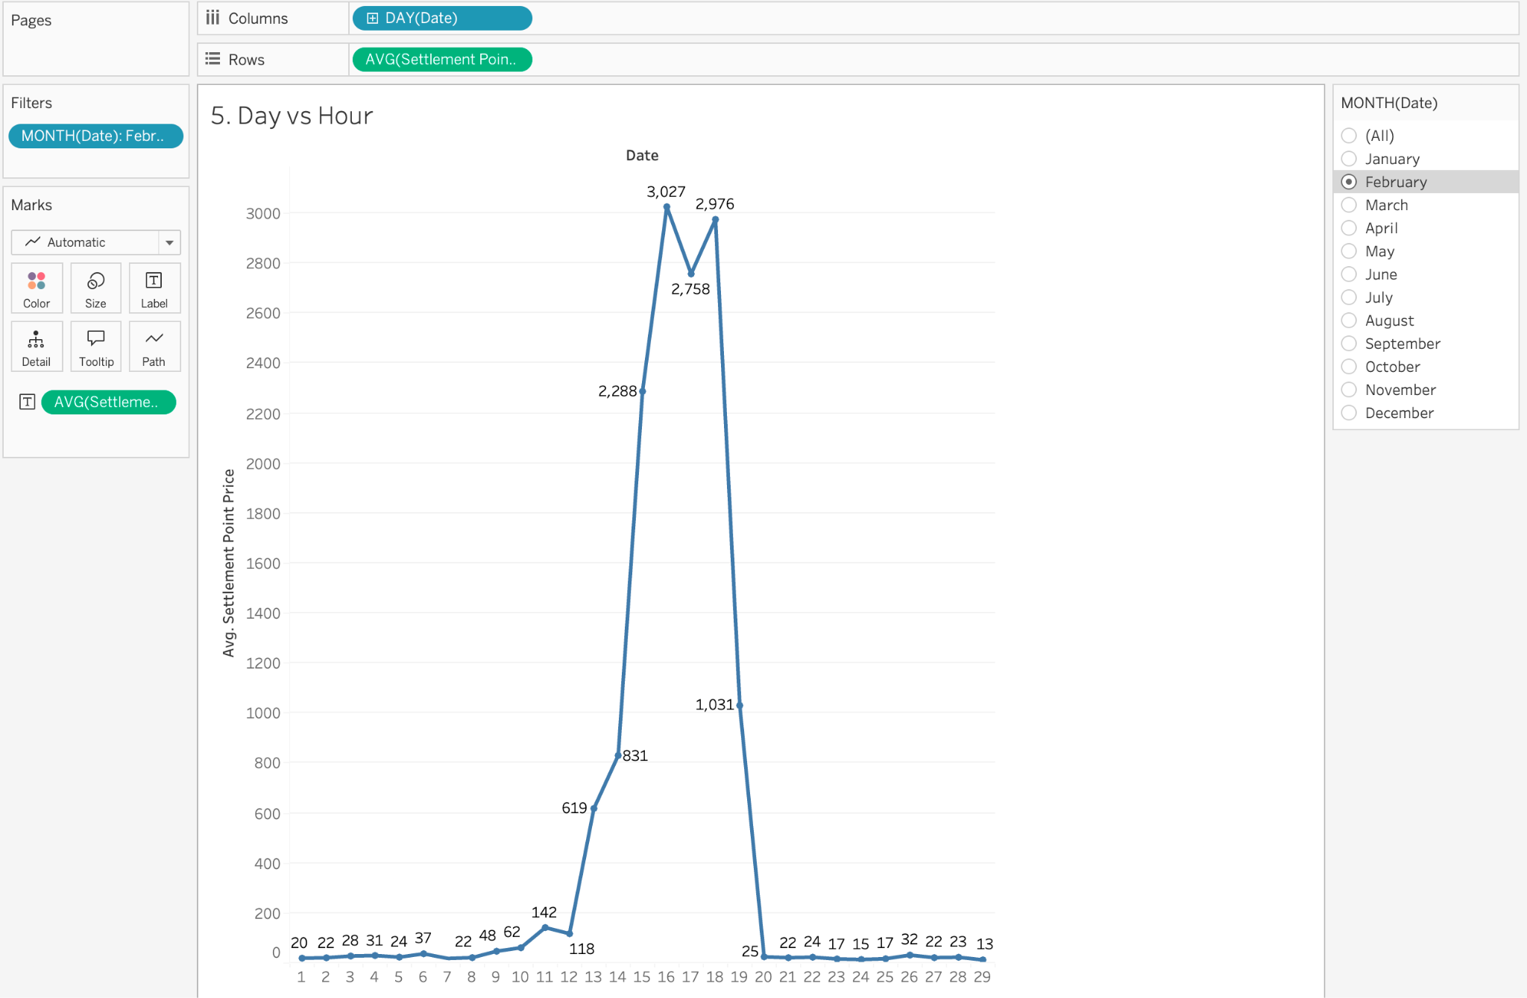

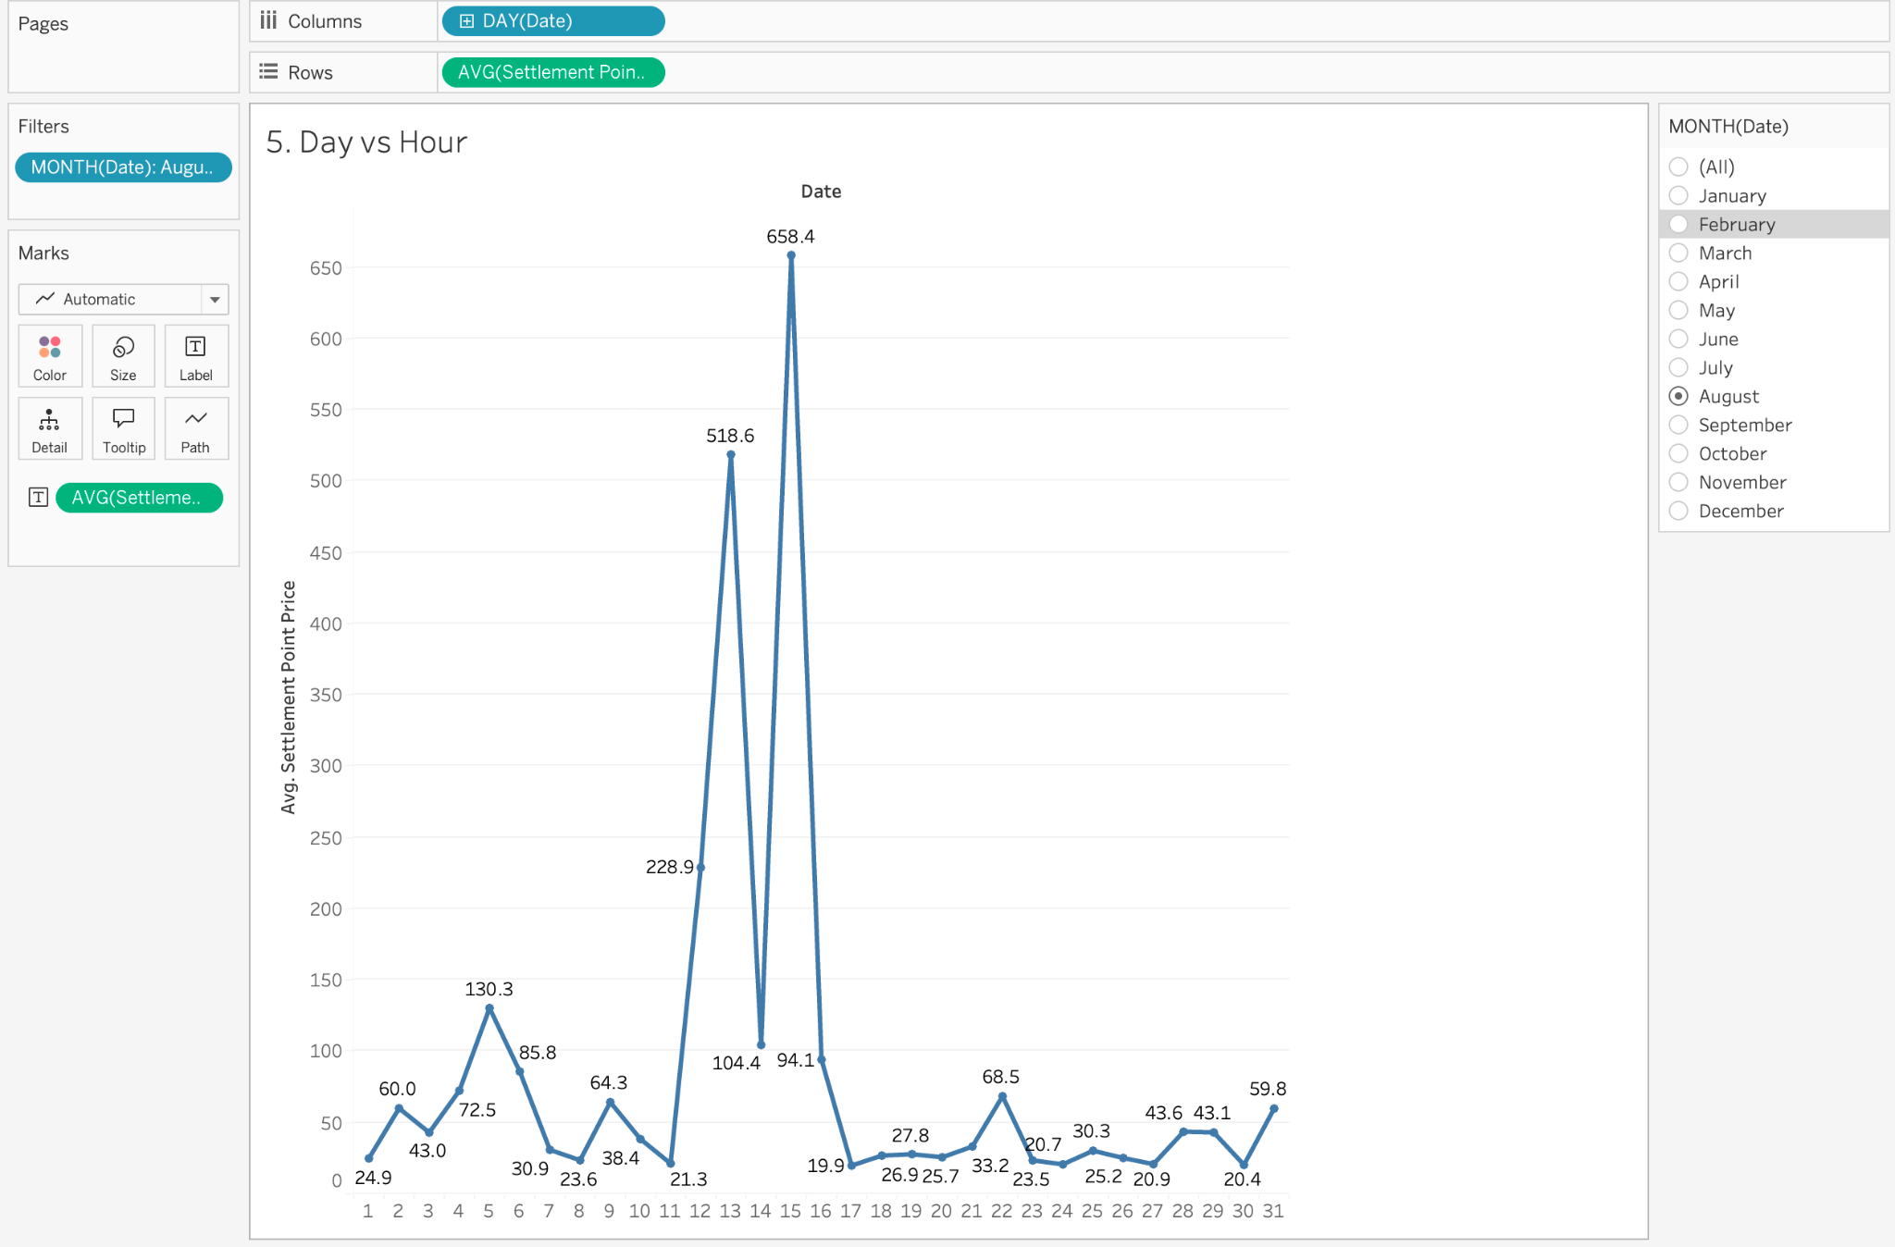

The amount of information is adjusted to day in order to further examine why the costs are so high in August and February. The graphic above provides a thorough analysis of a select few days that are significantly higher than the others. Only those two months see such high prices; the remaining months see pretty average pricing with few highs and few lows.

1. **Predictive Analytics:**

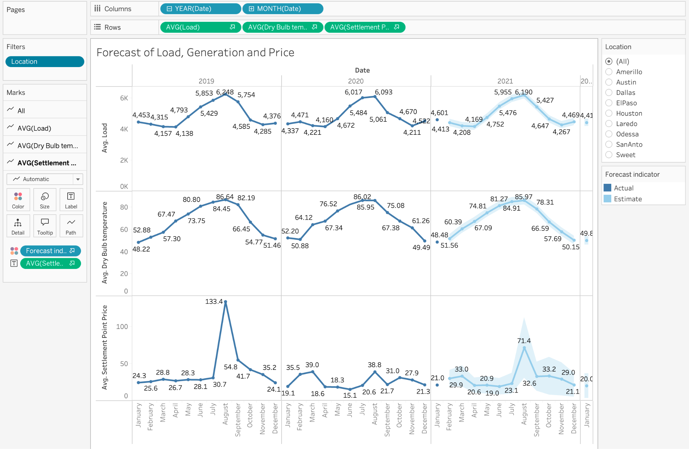

The above visual shows predictive analytics for electricity load on power grids, power generated and Electricity price in each year. Each graph depicts the demand , price is high in summer, driven by cooling needs. It also shows the predicted load, generation value and price. This helps the business stakeholders to understand the electricity consumption needs and optimize the supply and demand appropriately. Additionally, data can be filtered to each location.

1. **Prescriptive Analytics:**

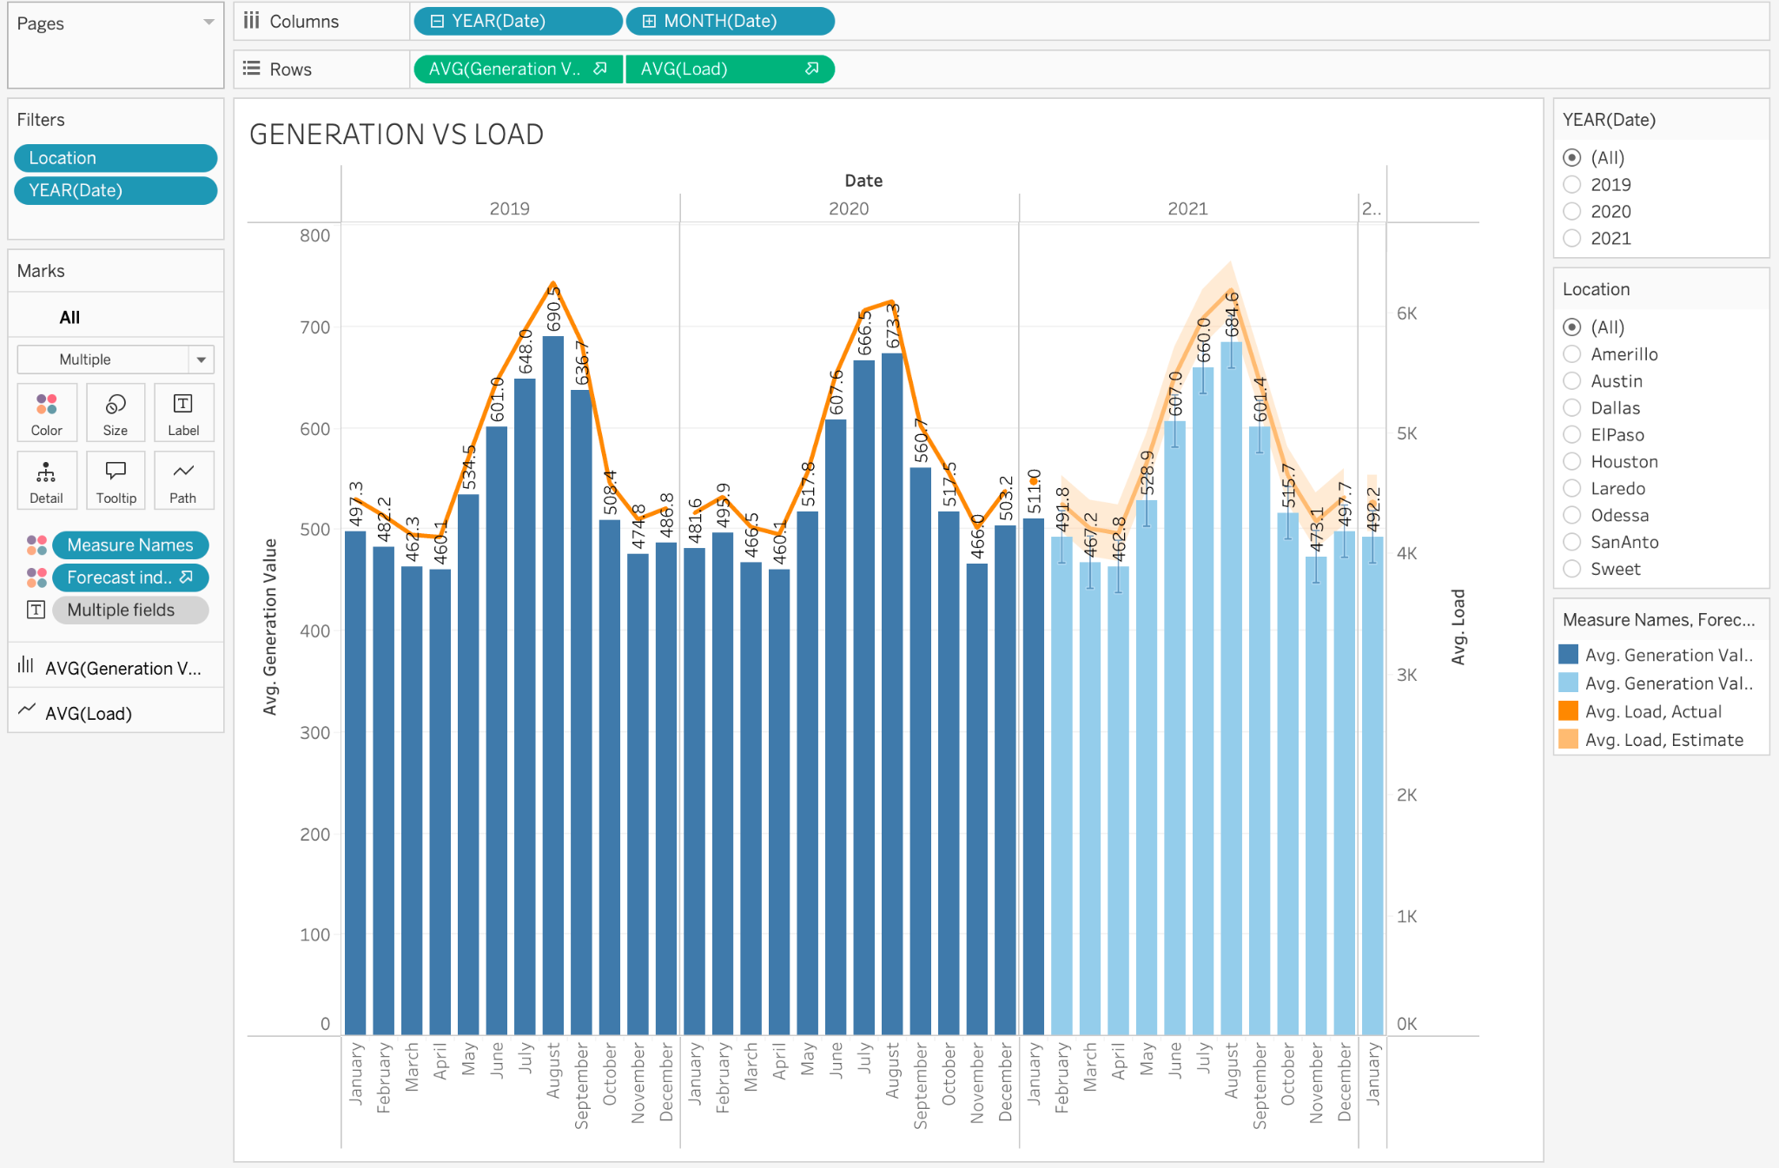

The above visual tool predicts the generation value for the next year and might be high in August again. To maintain the demand and load at an optimal rate, the generation should be more than the load, but still the load looks high in prediction. Necessary steps should be taken to increase the generation value.

**RECOMMENDATIONS:**

1. From the insights, the 2nd most contributing power generation is from wind, a nonrenewable energy source. In the future, non-renewable energy sources will be a great source of power generation. Focusing more on such sources will help businesses to enhance their profits in this sector and promote green energy.

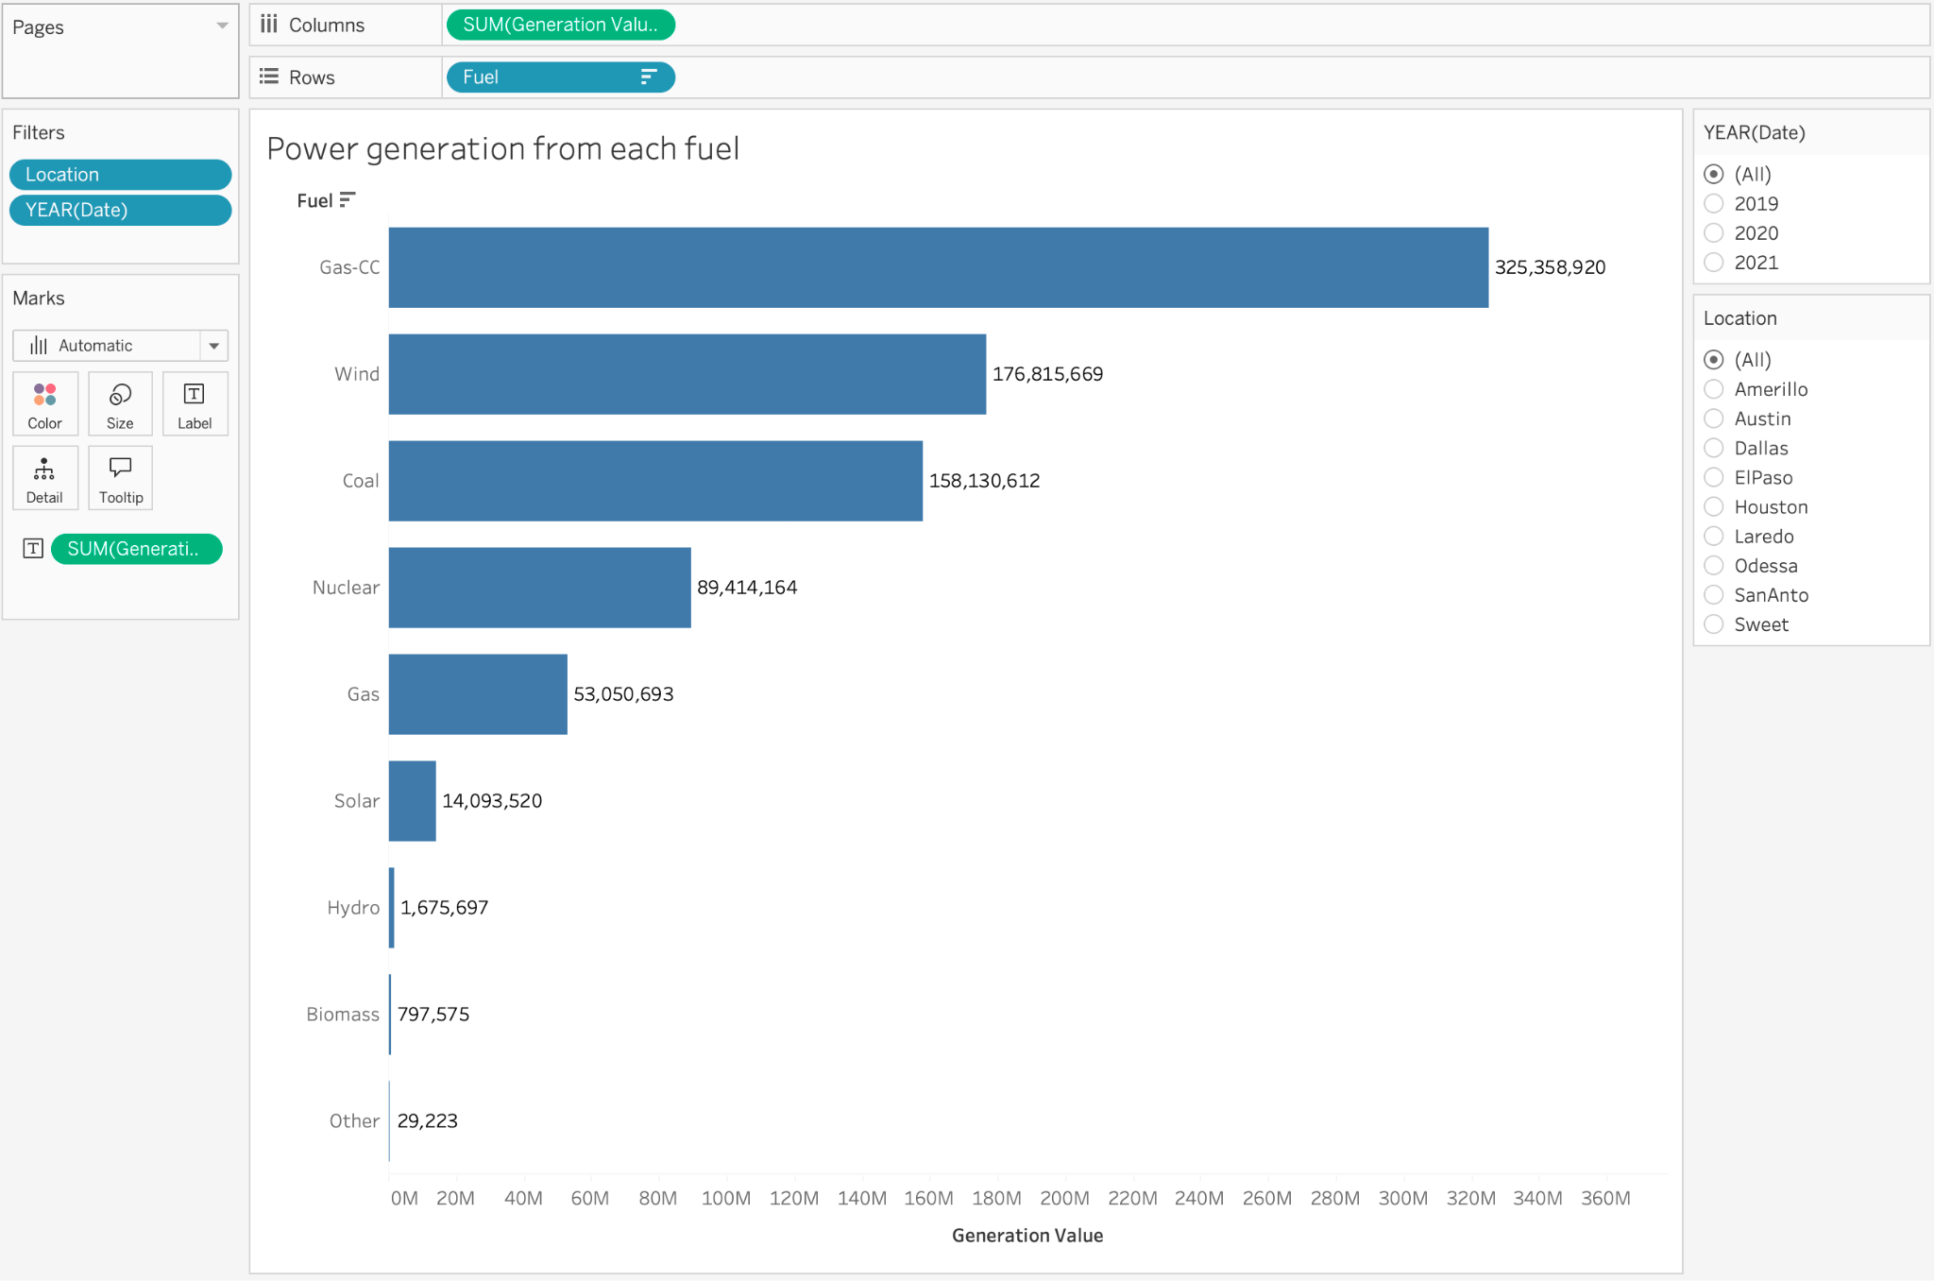

1. In August and February, for example, severe weather causes electricity prices to surge sharply. These surges are consistent with changes in dry bulb temperature, indicating a relationship between price volatility and weather.Invest in weather-based demand forecasting tools and create pricing models that take extreme weather conditions into consideration. To lessen stress during these times, promote energy-saving measures and dynamic pricing for customers.

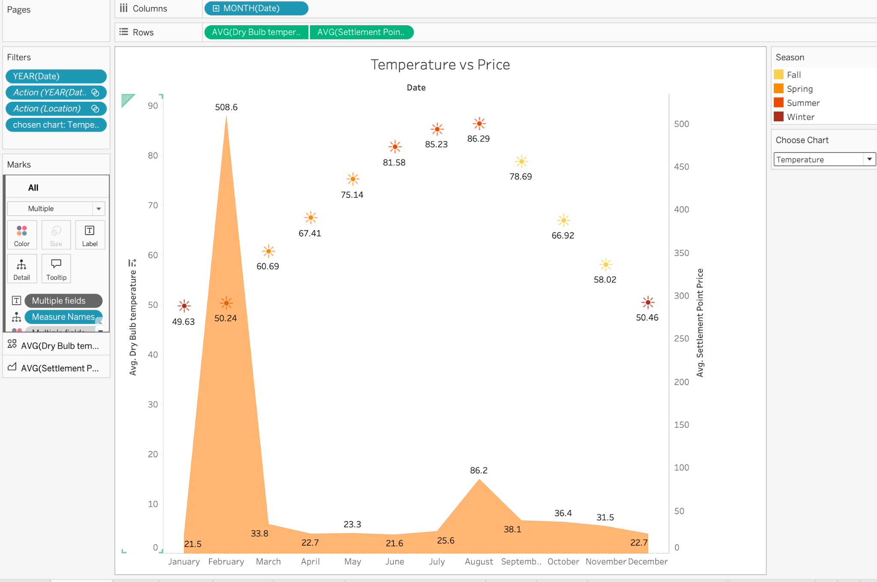

**EXTRA CREDITS:**

The below chart has a year filter and a choose chart filter. The year filter can be used to filter the data for each year.

Choose charts can be used to display charts for weather variables like temperature, humidity and wind speed. This feature is set up using parameters to have a dynamic dashboard and create interactivity.

Additionally, The data can be filtered according to location by clicking on the location in the map visual. This feature will enhance the interactivity and drill down data to that particular location.

For extracredits, map visual and forecast visuals are used which can predictive analytics and prescriptive analytics for this dashboard

